Erlasse und Gesetzestexte (eCH-0296)

Modul 1: Application Profile (AP) für ELI
Modul 1 des das die folgenden Standards berücksichtigt: AKN (inkl. FRBR und FRBRoo) sowie ELI (inkl. ELI-DL)

AKN
ToC:
- PART 1– Guidelines and Modelling
  - Scope,
  - File
    - Body,
    - Preamble,
    - Preface, etc.,
    - Notes,
    - Textual Content,
    - Character Set,
  - Metadata,
  - Amending Acts,
  - Language
- PART 2 – Document types
  - Acts
    - Use Cases,
    - Main Part
      - act or bill,
      - meta,
      - preface,
      - preamble,
      - body,
      - conclusions,
      - attachments),
    - Annex
      - meta,
      - preface,
      - mainBody,
      - attachments
  - International Agreements

PART 1 - Scope:
- AKN4EU is a localisation of Akoma Ntoso for EU legislation which includes Common vocabulary (CoV) semantic and logical concepts.
- The documentation includes the AKN4EU model for documents, components and annexes and the naming convention of its AKN4EU files
- For each standardized AKN4EU file or content section, including the preamble and the body, AKN4EU specification details the [rules and] content model of legsilative (and other) documents guaranteeing the full use of the ELI URI and specific metadata, with a focus on the context of the Ordinary Legislative Procedure (source?)
The AKN4EU baseline version contains the following use cases for the EU acts (and proposals thereof):
AKN4EU Acts | Swiss equivalent
Decision | Beschluss
Directive | -
Regulation | Erlass oder Gesetzestext
Implementing Decision | -

This includes international agreements, texts of the European Parliament and proposals of acts of the European Council Financial Statements. In addition the low level structure for the figure, the mathematical formula and the tables and mark-up for a table of content or a table of annexes as well as language code (2-letter and 3-letter) for multilingual documents are covered.
The Swiss equivalent to AKN4EU acts should include Regulation (Erlasse und Gesetzestexte), here used as umbrella term for texts, acts and proposals of legislative bodies, in the widest sense as described in the original AKN4EU specification for EU legislation. Decisions (Beschluss) as well as Implementing Decisions (Ausführungsbeschlüsse) exist in Swiss law, however, the Swiss federal parliament does not use the latter term as a formal category; usually the federal council enacts ordinances (Verordnung). EU Directives, while not directly applicable to Swiss law, are translated into national law. Therefore only the categories Decision and Regulation are directly relevant for the Swiss equivalent of AKN4EU whereas Directives are defined directly by AKN4EU.

PART 1 - model for documents, components, annexes
A AKN4EU document consists of a cover page and one or more components. A component can be an explanatory memorandum or a legal text (Regulation), among others, which can be seen as subdocuments with their own structure and AKN document type.
This corresponds to Akoma Ntoso which is a standard for the mark-up of documents: The immediate subelement of <akomaNtoso> is a document type element. Each document type element has a mandatory attribute @name to specify the type of document (<act>, <bill>, <doc>, …) or collection of documents (<documentCollection>). The main content of the <documentCollection> is the <collectionBody>. It is composed of a list of <component> elements, each of which allowing to link to the corresponding subdocument or put the content.
The structural model of an an AKN4EU file for “official documents” uses <documentCollection>. Each subdocument MUST be referenced inside the <documentCollection> in a specific <component> element. One AKN4EU file MUST contain not more than ONE subdocument content. Every subdocument can have its own document type (<act>, <bill> and <doc> or even <documentCollection>).
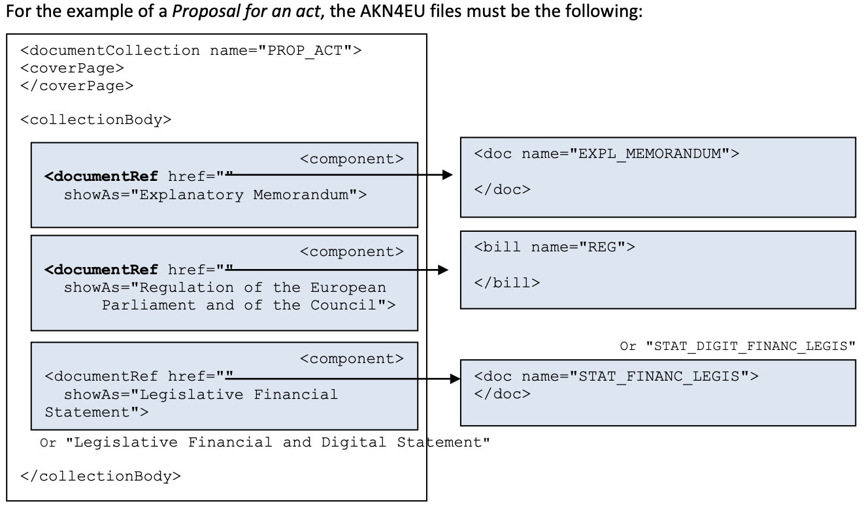
The Swiss equivalent to the AKN4EU model for documents and components usually does not require a cover page. The main component is a legal text: As explanatory memorandums are part of the Federal Council Dispatch (Botschaft des Bundesrats) or the Explanatory report (Erläuternder Bericht des Bundesrats) in Swiss legislation they are not included in the the legal act itslef, but its own separate document. In terms of types of documents Swiss legislation can include <act>, <bill> and <doc> or even <documentCollection> and therefore follows the guidelines for AKN4EU.
Other than components, EU acts can include attachments such as annexes, table of annexes or other EU acts. An annex (in the strict sende) is ‘used to present material separately from the body of the enacting terms [of an act], because it is voluminous or technical or both. Examples of such material might be rules to be applied by customs officers, doctors or veterinarians (such as chemical analysis techniques, sampling methods and forms to be used), lists of products, tables of figures, plans and drawings, etc. An annex is by its very nature an integral part of the act, and therefore there is no need to state this in the provision referring to the annex.’
In Akoma Ntoso, the content of, or reference to annexes is put in the <attachments> section of a document type element. <attachments> is composed of a list of <attachment> elements, each of these elements can contain the link to, (or the content) of the corresponding annex.
In AKN4EU, the content of an annex MUST be in a <doc name=”ANNEX”> and the content of each annex is in a specific AKN4EU file. Each annex MUST be referenced in the master document in an <attachment> element, using a <documentRef> element.
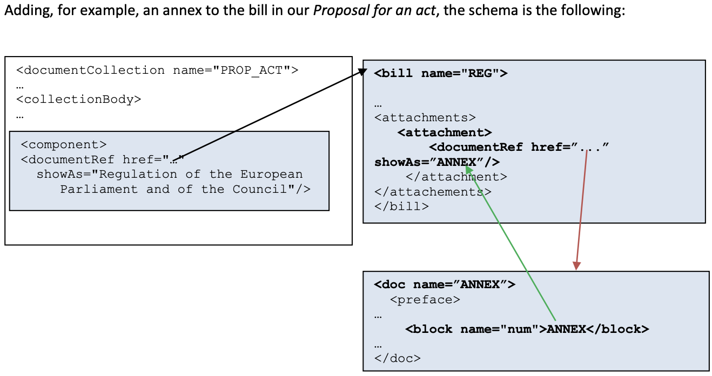
Sometimes, when there are a lot of annexes, all the annexes are preceded by a “table of annexes” (similar to a table of contents). In AKN4EU, this is represented as <attachment> element (MUST) in the master document. The <attachment> contains an <interstitial> element containing table of contents.
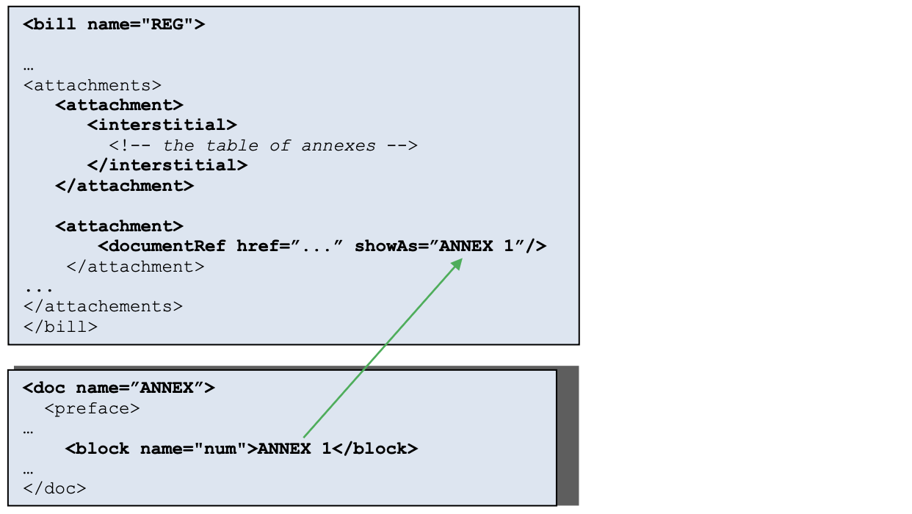
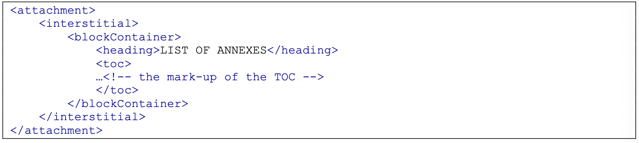
In AKN4EU, an EU act or bill can also have one or more attachment(s) containing other legal acts. These are “attachments” and not “annexes”.
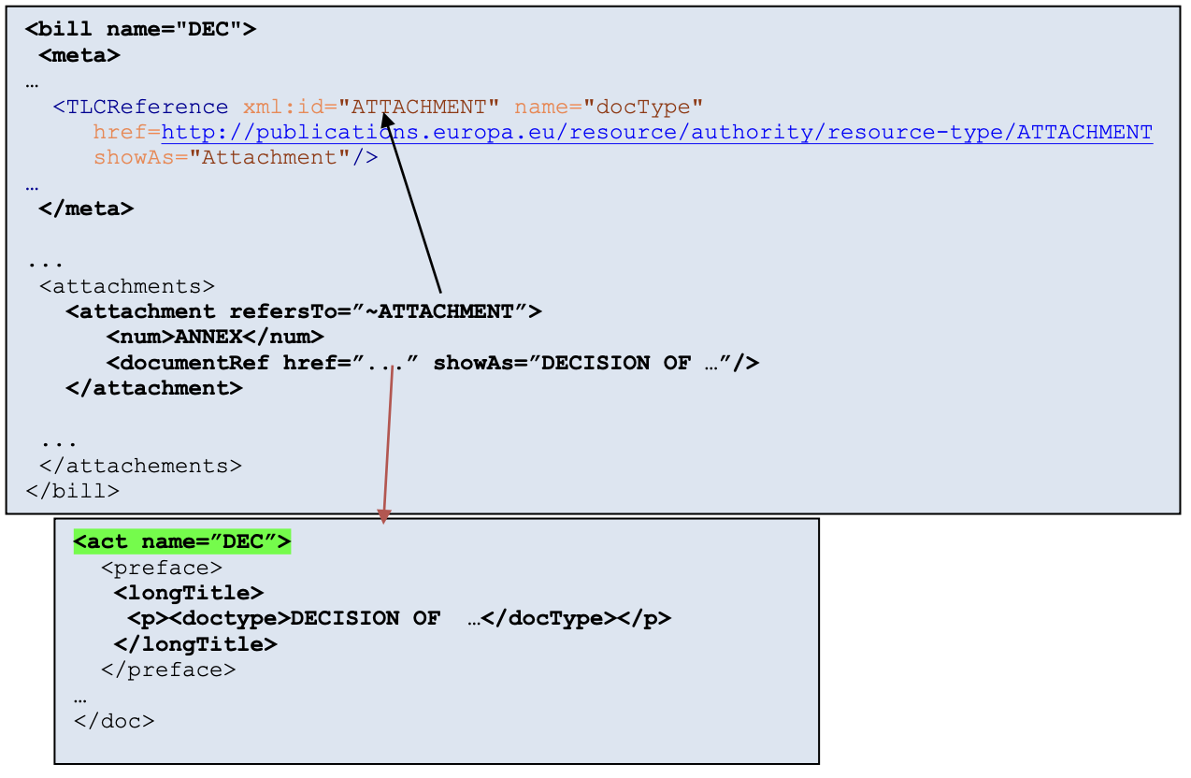
The Swiss equivalent to the AKN4EU model for documents and components includes annexes, table of annexes and attached acts as well.
The AKN4EU file naming convention includes handling of linguistic variants issued in the legal decision-making process; an AKN4EU manifest is contained in a file of the format ZIP archive. It must contain at least an AKN4EU file starting with the prefix ‘main-’, of the type <documentCollection> (each main component of a business document is a specific AKN4EU file) and may contain other associated files and subfolders (together the AKN4EU_LEG package). All AKN4EU files and referenced resources like images must be placed at the same level (root directory). The name of any AKN4EU file must comprise information on its language (language code) and translation must contain information regarding the translation (original language, version of translation). The naming convention requires a CUID (fallback file name; MUST) while all the information used for the name of an AKN4EU file MUST be part of the metadata of this file and the following information CAN be part of the filename: drafting version of the document, with or without the drafting version of the component, original language (lowercase ISO 639-1 2-letter code), the translation version. This ensures that even a Proposal for a Regulation in an initial phase of drafting has at least a CUID as technical identifier and when the document is finalized EU acts receive a COM number (+ an official version) in place of CUID and draft version.
The Swiss equivalent to the AKN4EU of the file naming convention should conform to thiese guidelines.
PART 1 - 2 The AKN4EU file: the mark-up for <body> and <mainBody>
2.1 Introduction: the Akoma Ntoso families of elements for the <body>/<mainBody>
2.2 The AKN4EU principles
2.3 The AKN4EU content model
There are 3 levels of elements:
- high level structures: either named <part>, <title>, <chapter>, or <section> (incl. hierarchical representation <num> and optional <heading>) or unnamed <subdivision> (hierarchcal model) or <division> (flat model).
  - In named structures, each name of the structure corresponds to a level of hierarchy and includes one or more core structure(s) or high level structure(s).
  - Unnamed structures are represented as <subdivision> (hierarchical model) contain <num> and <heading> along with one or more core structure(s) or a sequence of unnamed structures (<subdivision>). Alternatively, unnamed structures can be represented as <division> (flat model) with a mandatory <num> and <heading> element as well as @class attribute containing "type_"{number}, where {number} is indicating the level in the hierarchy ("1" = first level, "2" = second level, …). The value of the @class attribute must be coherent with this underlying hierarchy of <division>.
- core structures:<article>, numbered (<num>) or unnumbered <paragraph>, or independent <level>. The core structure groups the basic elements available; The simplest document must have at least one of these structures. Which structure is available for adocument is defined at the level of the AKN4EU file and its type.
  - An <article> is the basis structure of EU acts and must contain a <num> (<heading> is optional) and at least one numbered (or unnumbered) <paragraph> with at least a simple block of text inside a <content>/<p> element. The “numbered paragraph” can be a table inside a <content>/<table> element, one or more <list> or <hcontainer> elements or a sequence of at least two <subparagraph> elements. The "unnumbered paragraph" differs in that it can only have one <subparagraph> inside.
- low level structures: <subparagraph> , <list> with multiple <point>or <indent> and an optional introductory and/or final part, or a table / scientific formula / figure as <hcontainer> which itself can contain a <subparagraph> or >list> and optional legend (<hcontainer>).

AKN4EU uses the following named structures relevant for identifiers for building URLs
- Title (element <title>), => the only relevant for identifiers for building URLs
7.4 Local reference

The value of the @name attribute of any Akoma Ntoso document type element MUST be the authority code from the Authority table "resource-type"
Parlamentswörterbuch
AKN4EU PART 1 - 7.6 Table of content: consisting of a <blockContainer> with an optional <heading> followed by the <toc> element for the mark-up of the annex
This includes any resources that are in another format (e.g., jpeg, png, SVG or MathML).
Permitted subfolders are media and renditions, with subfolders html, pdf and Word (not mandatory).
For example, if the English variant of an AKN4EU_LEG package is named PROP_ACT-COM(2013)_824-final-en.leg (‘-en-‘ contains the 2-letter code of English language) the corresponding AKN4EU_LEG package of the French variant MUST necessarily be named : PROP_ACT-COM(2013)_824-final-fr.leg (‘-fr-‘ contains the 2-letter code of French language)
Older versions of EU acts were allowed to have a <subsection>.
Example ofthe hierarchical model: The heading sequence III. A. 12., III. A. 13., III. A. 14., etc. where each level is a <subdivision>: 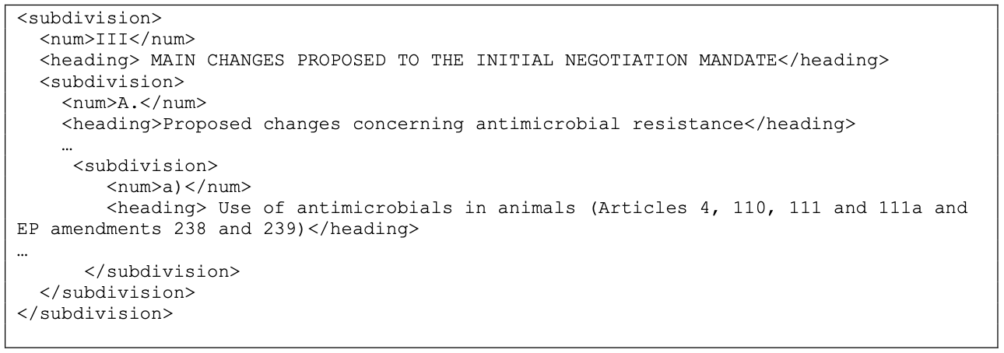
The @class attribute is required because the hierarchical structure is represented in flat way.
Example of the flat representation (same as above): 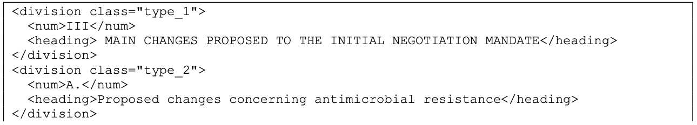
For example, a <division classe="type_3"> cannot directly follow a <division class="type_1">.
A "numbered paragraph" always starts with a <num> while "unnumbered paragraph" cannot start with a <num>.
Example of a «simple block of text»: 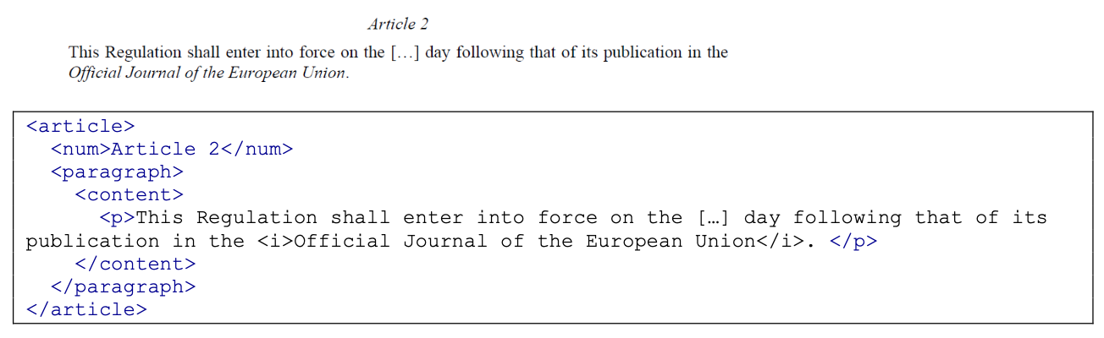
Example of a «numbered paragraph»: 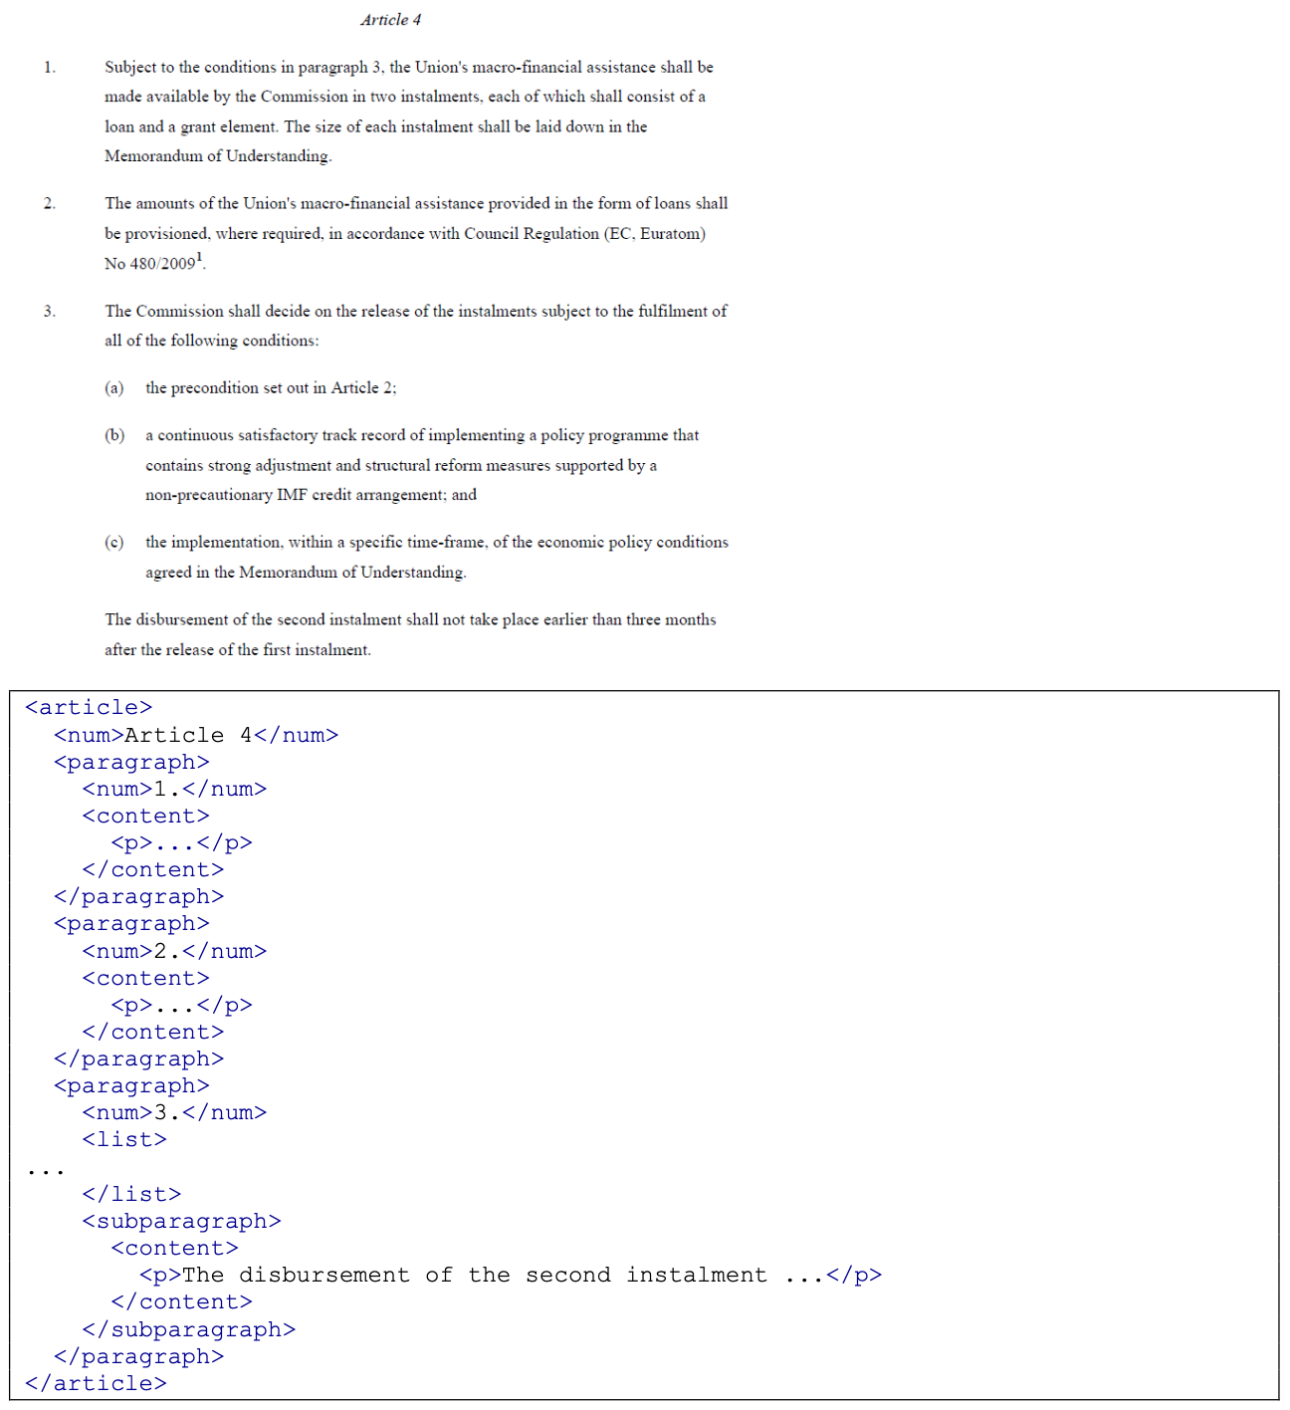
Example of a «unnumbered paragraph»: 